**NY Parking and camera violation data analyses**

**Screenshots:**

**STEP: 1**

**Download data set**   
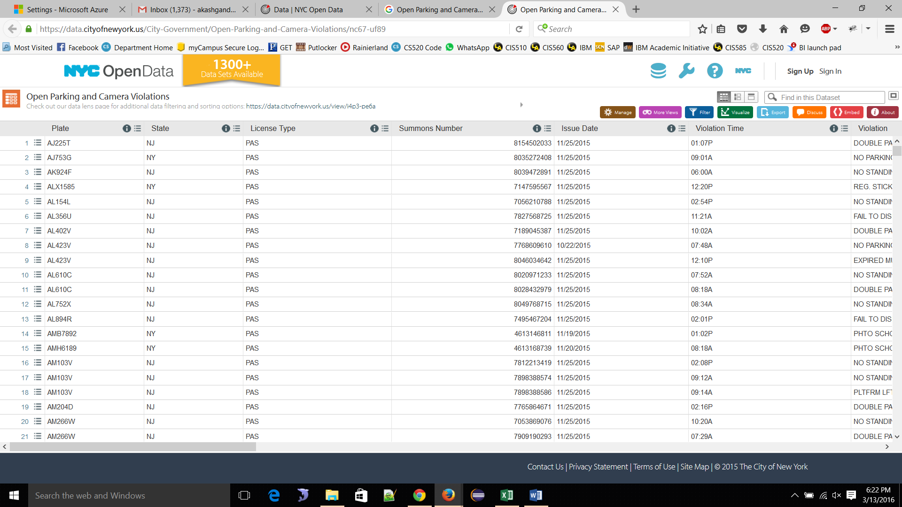

**STEP: 2**

**Collaborated Azure sandbox**

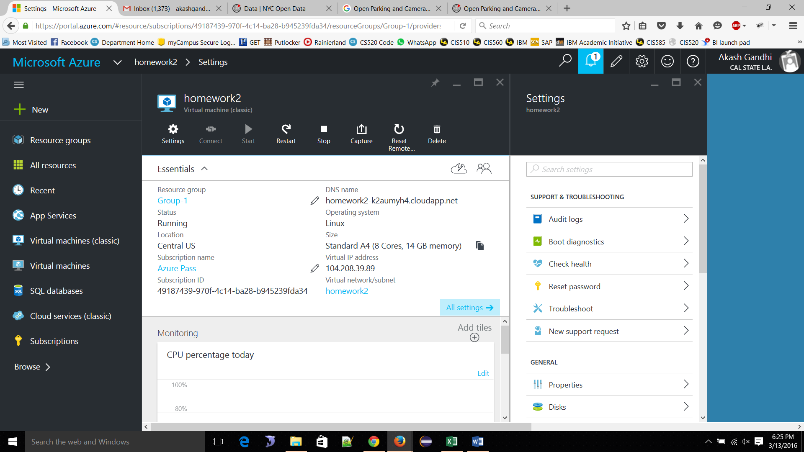

**STEP: 3**

**Support Horton works sandbox**:  
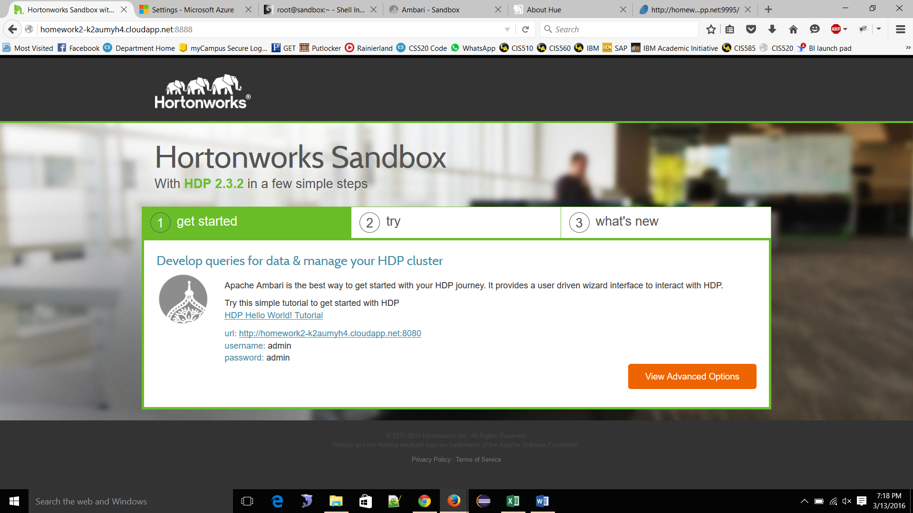

**STEP: 4**

**Shell in a box:**

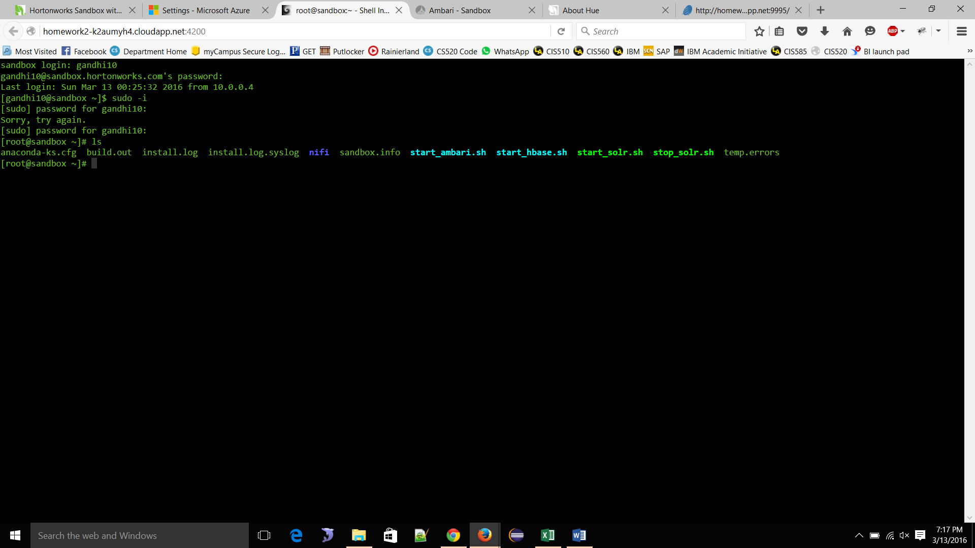

**STEP: 5**

**Connection with Ambari Dashboard:**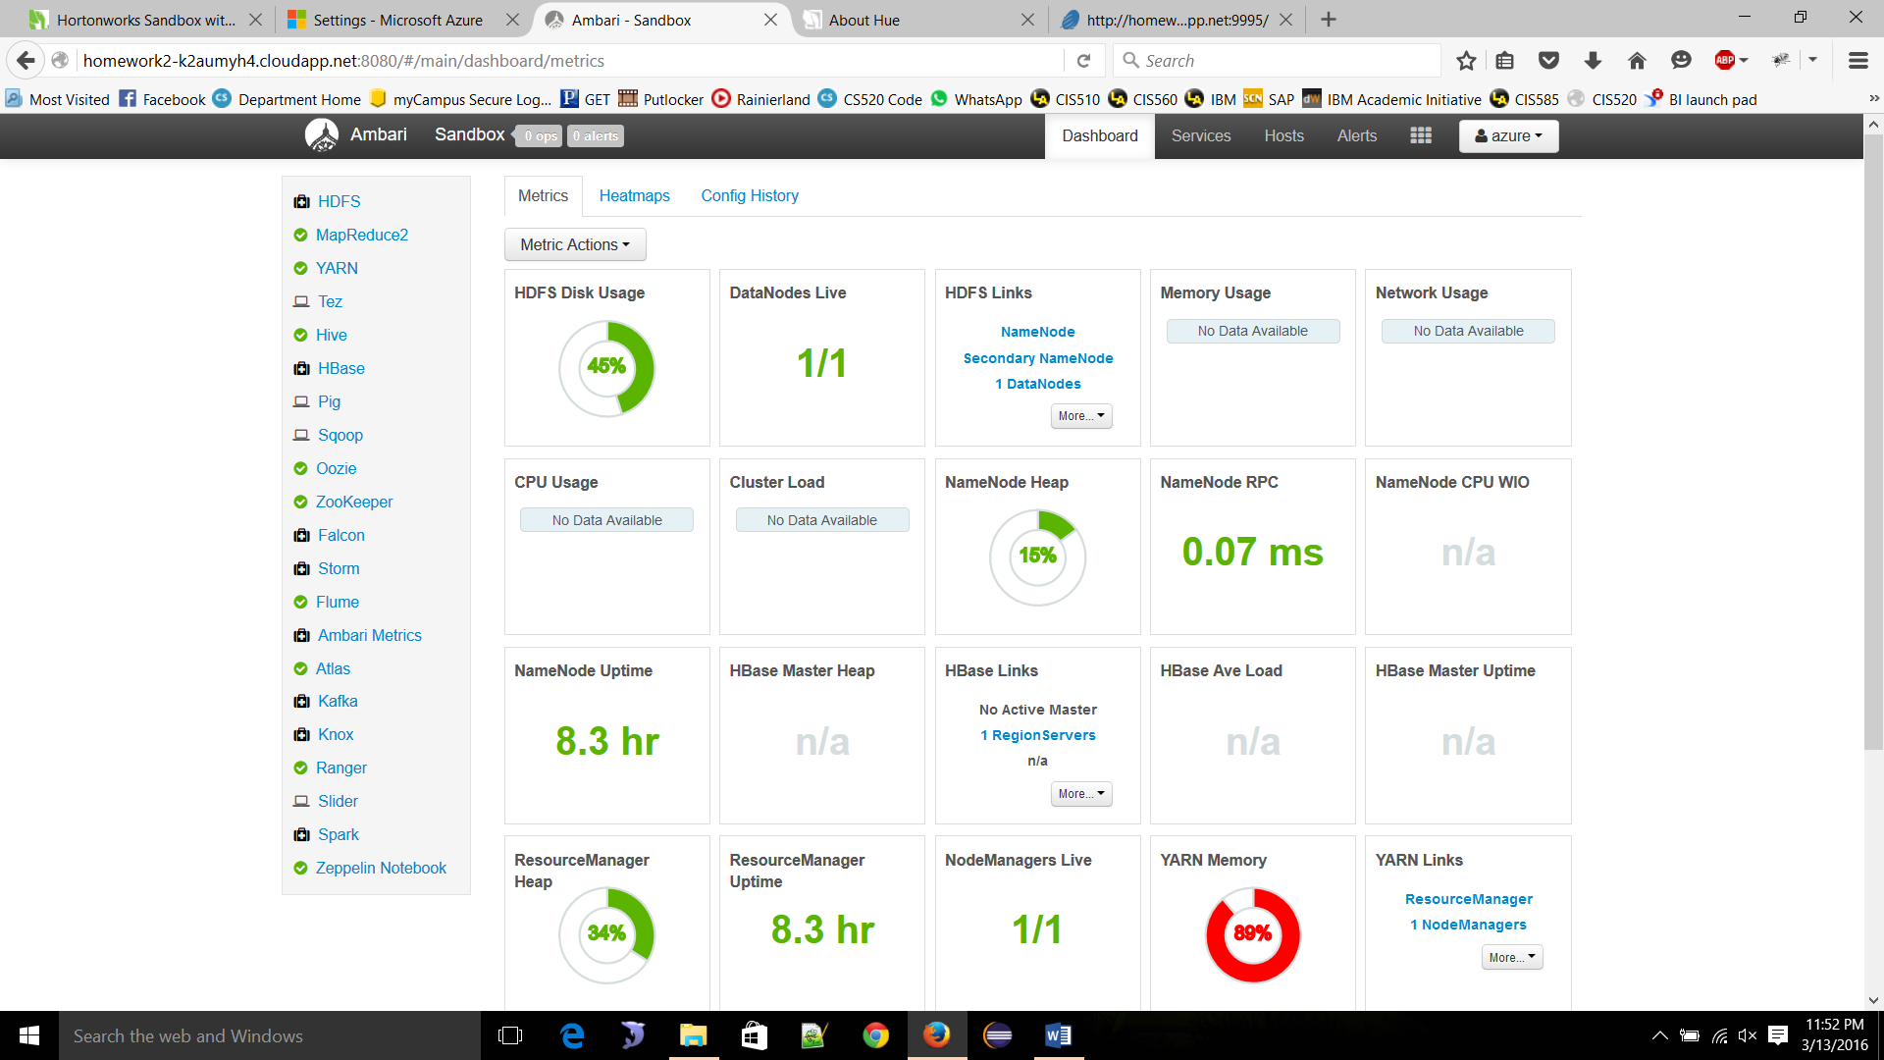

**STEP : 6**

**ABOUT HUE**

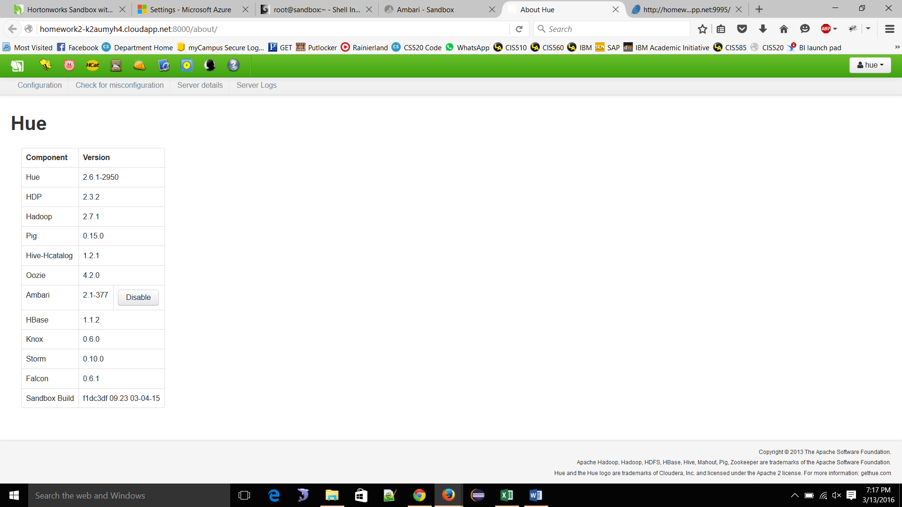

**STEP : 7**

**Visualization** Zeppelin**:**

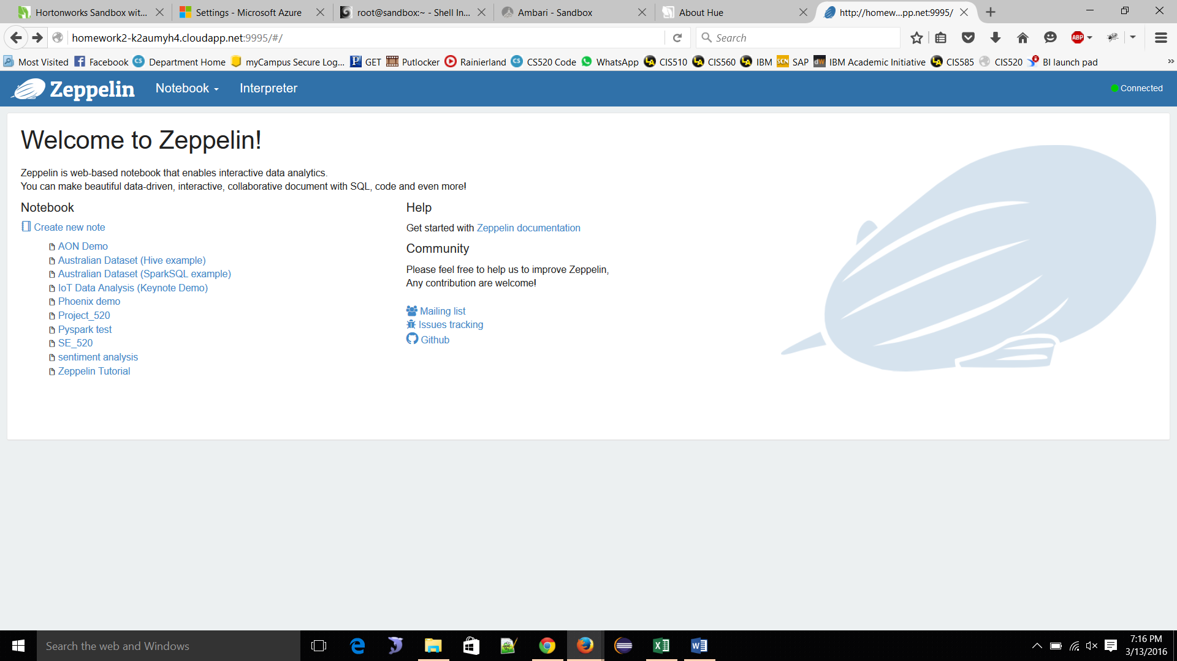

STEP: 8

**Database name in ambary**  
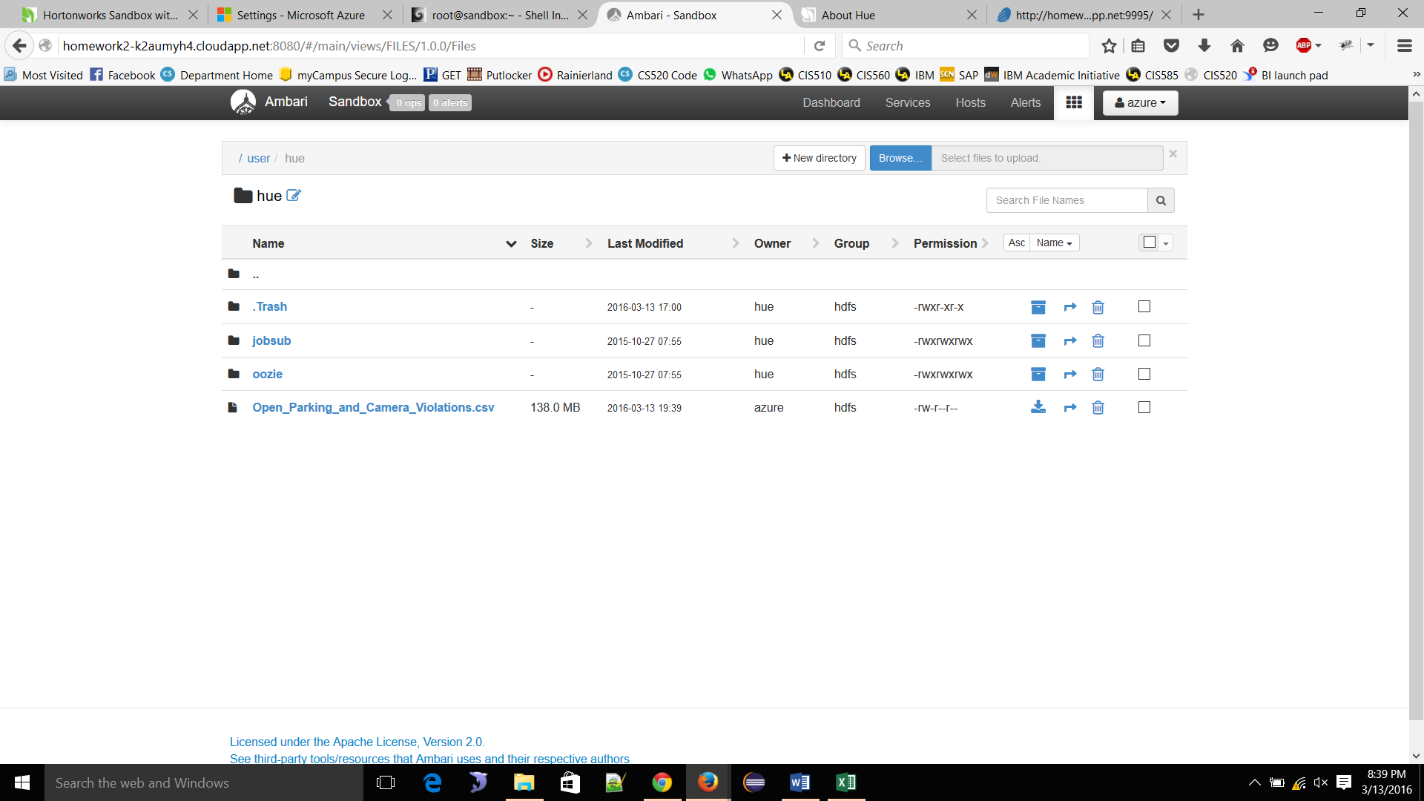

**STEP : 9**

**Beeswax (hive UI) query**

**Data path: user/hue/open_parking_and_camara_violatation.csv**

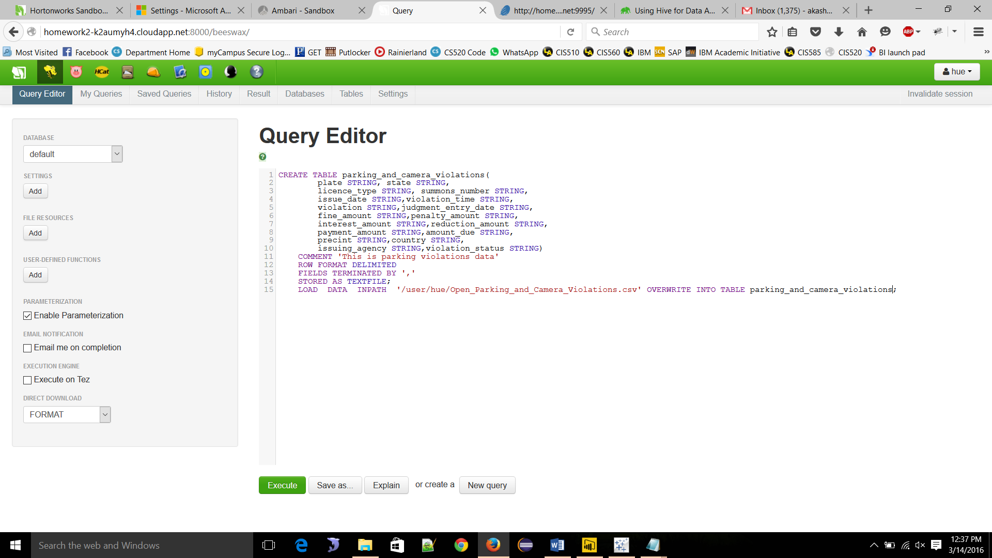

**STEP : 10**

**Table**

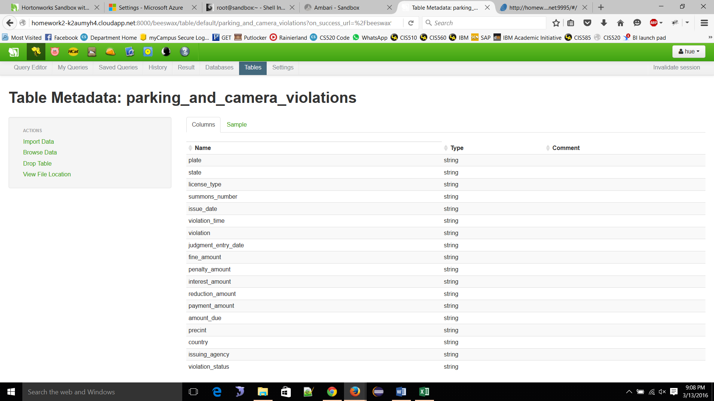🡪 STEP : 11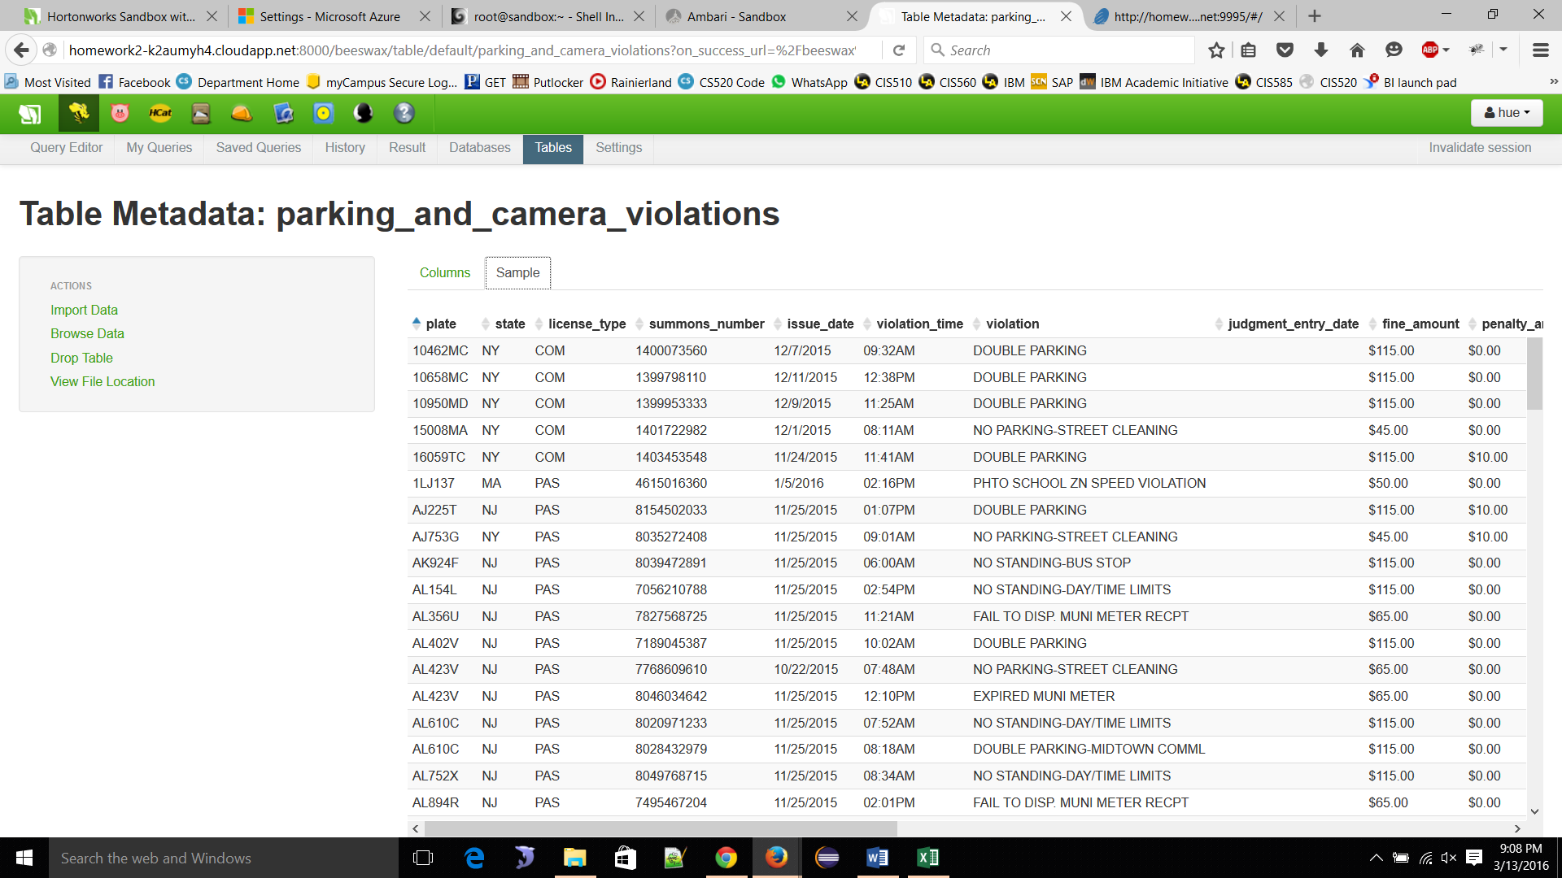

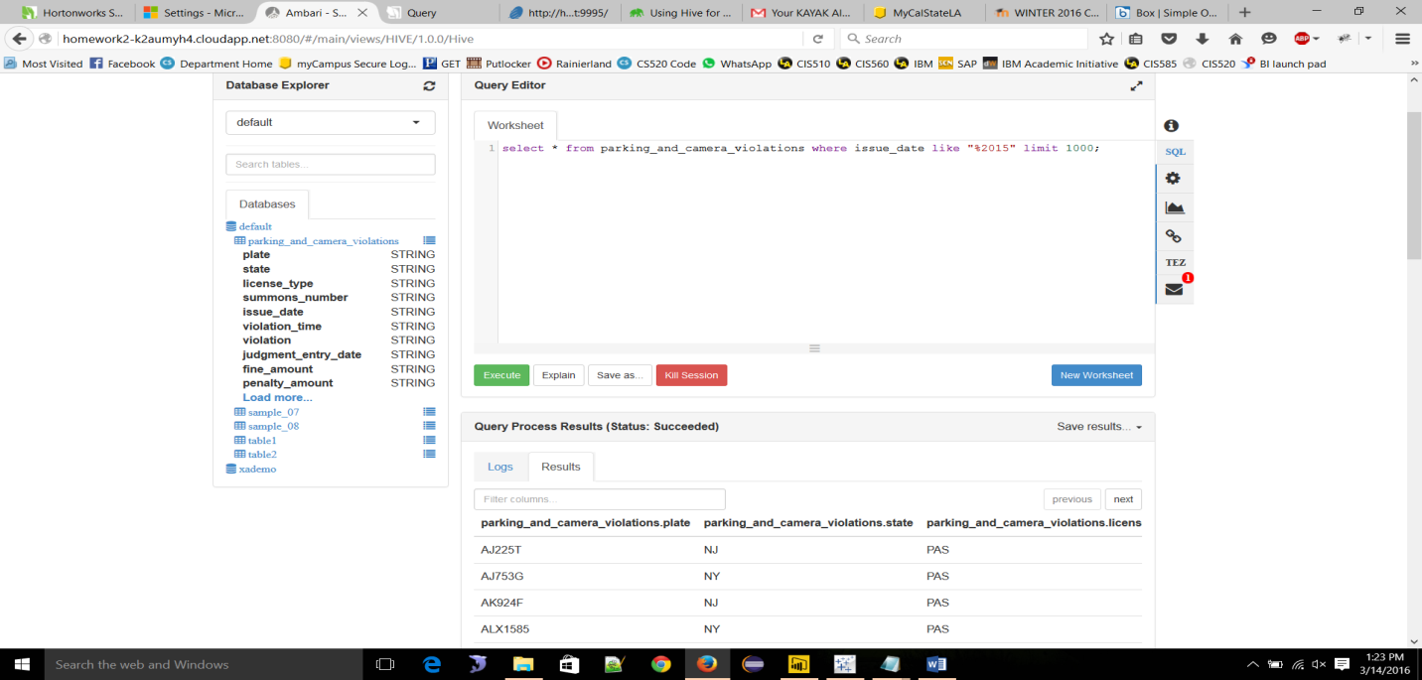

**STEP : 12 visualization Zeppelin**

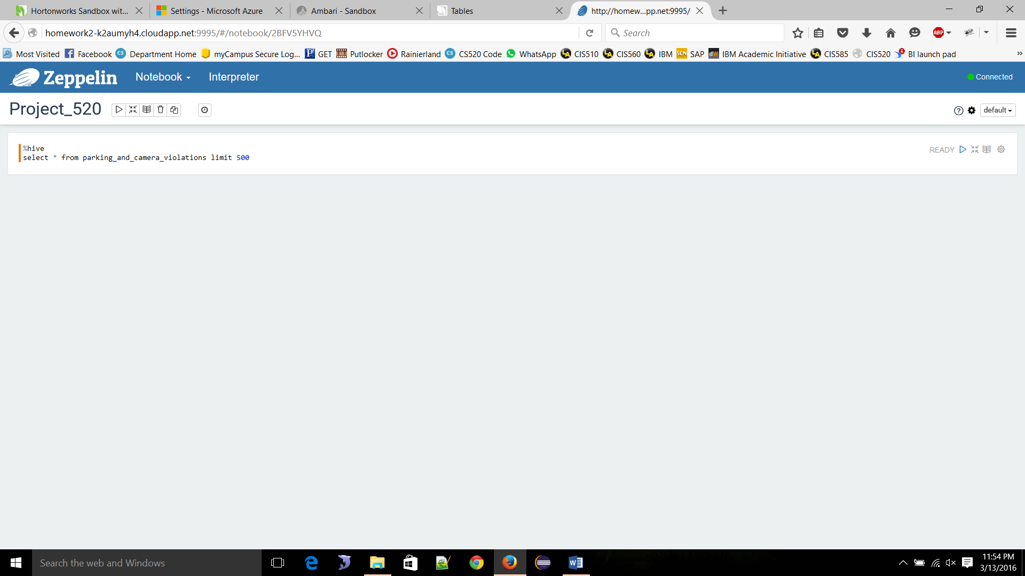

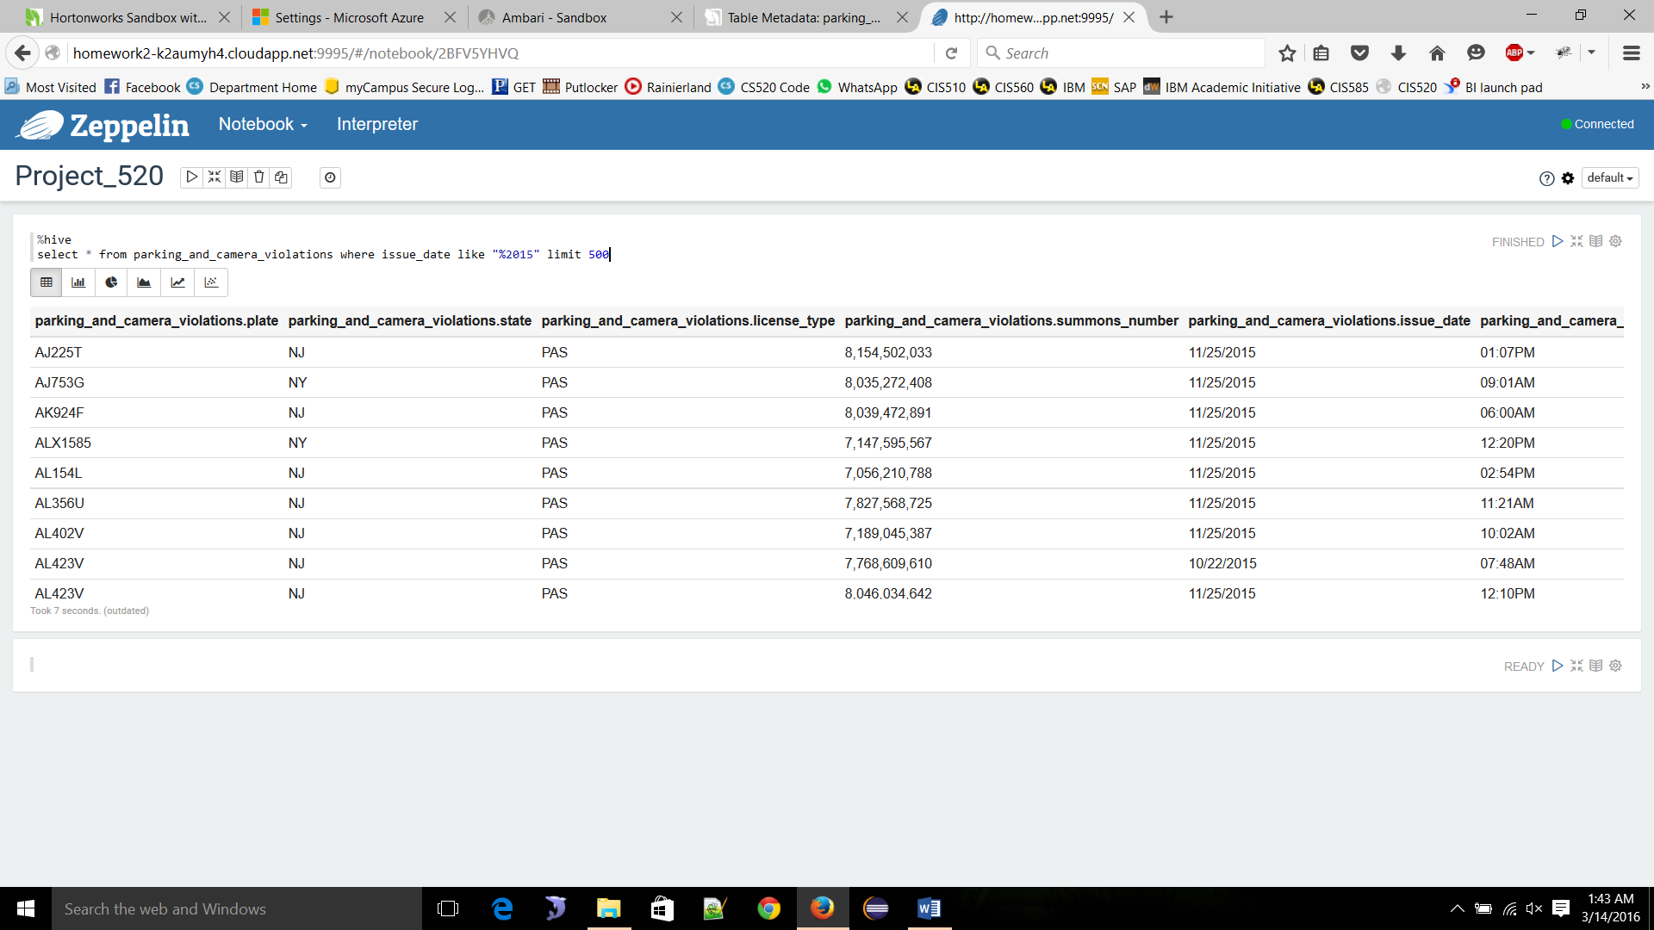

**🡪 Violation Issue time**

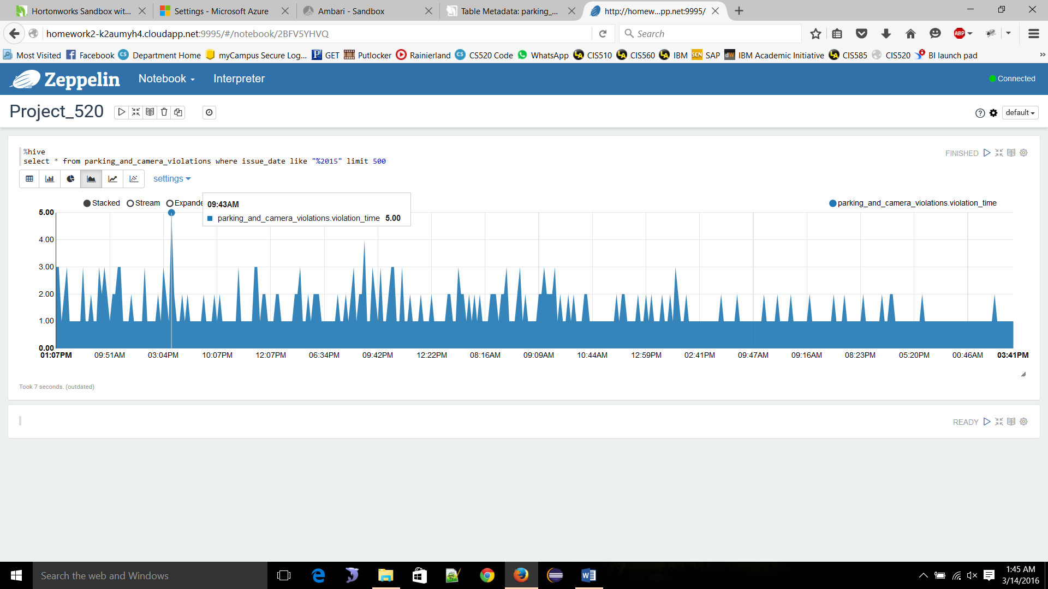

**🡪Violation Issue time**

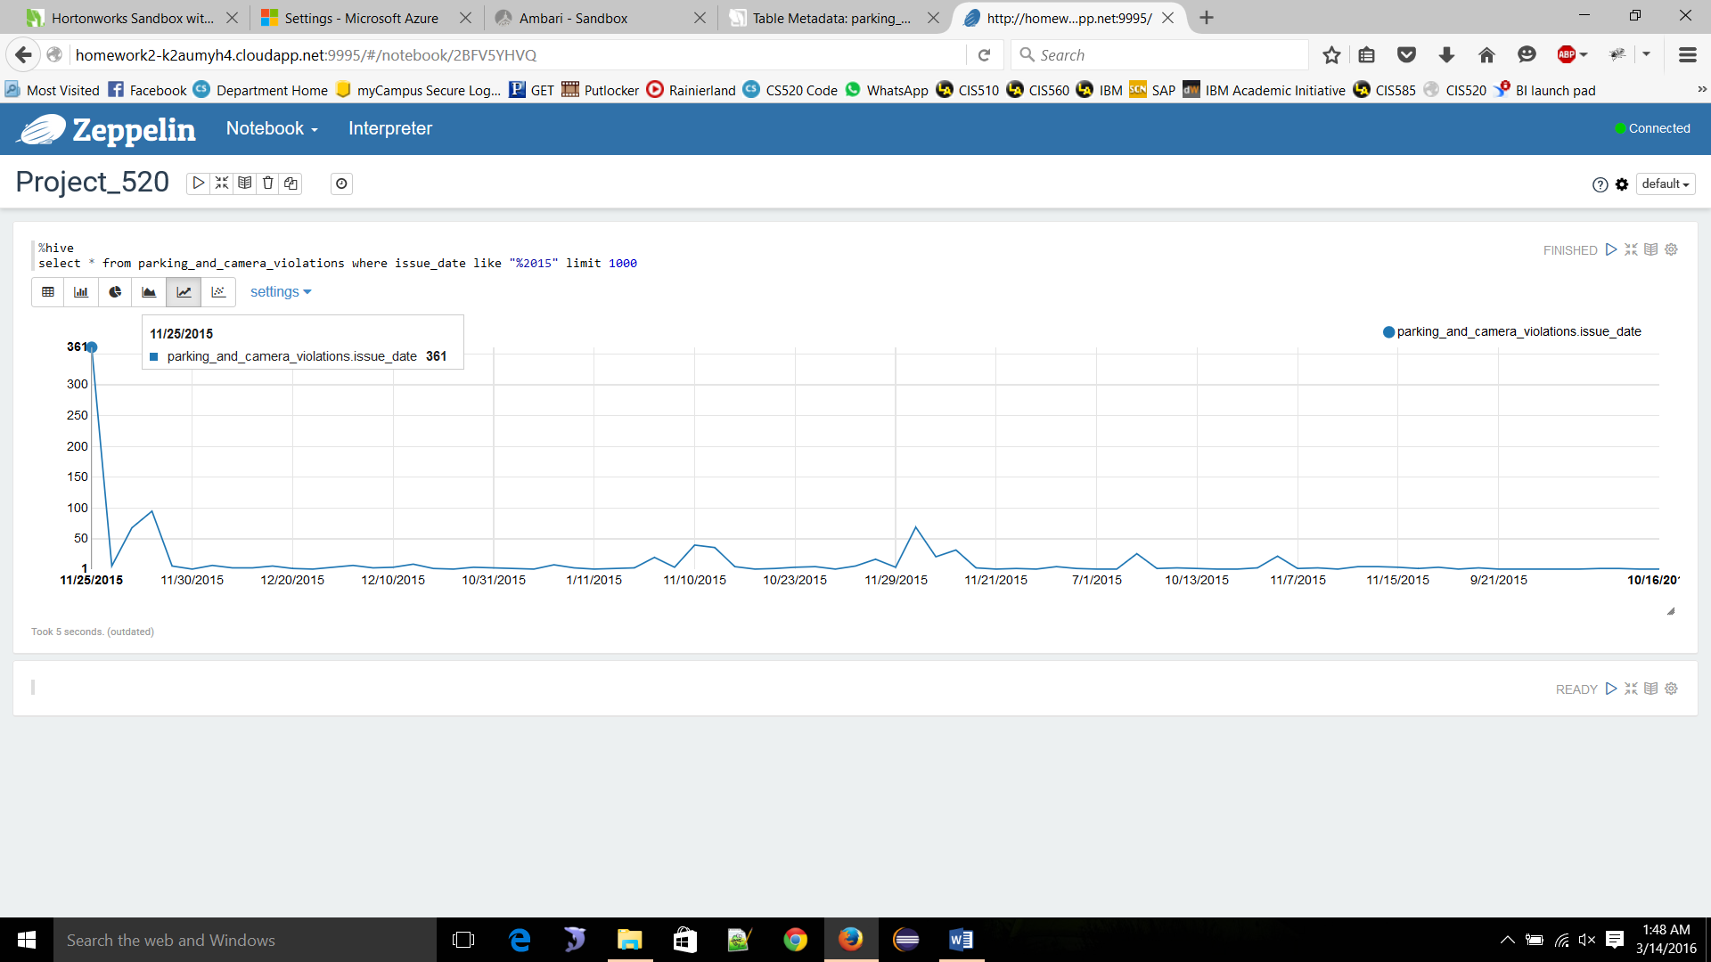

**🡪 Violation Issued Department**   
  
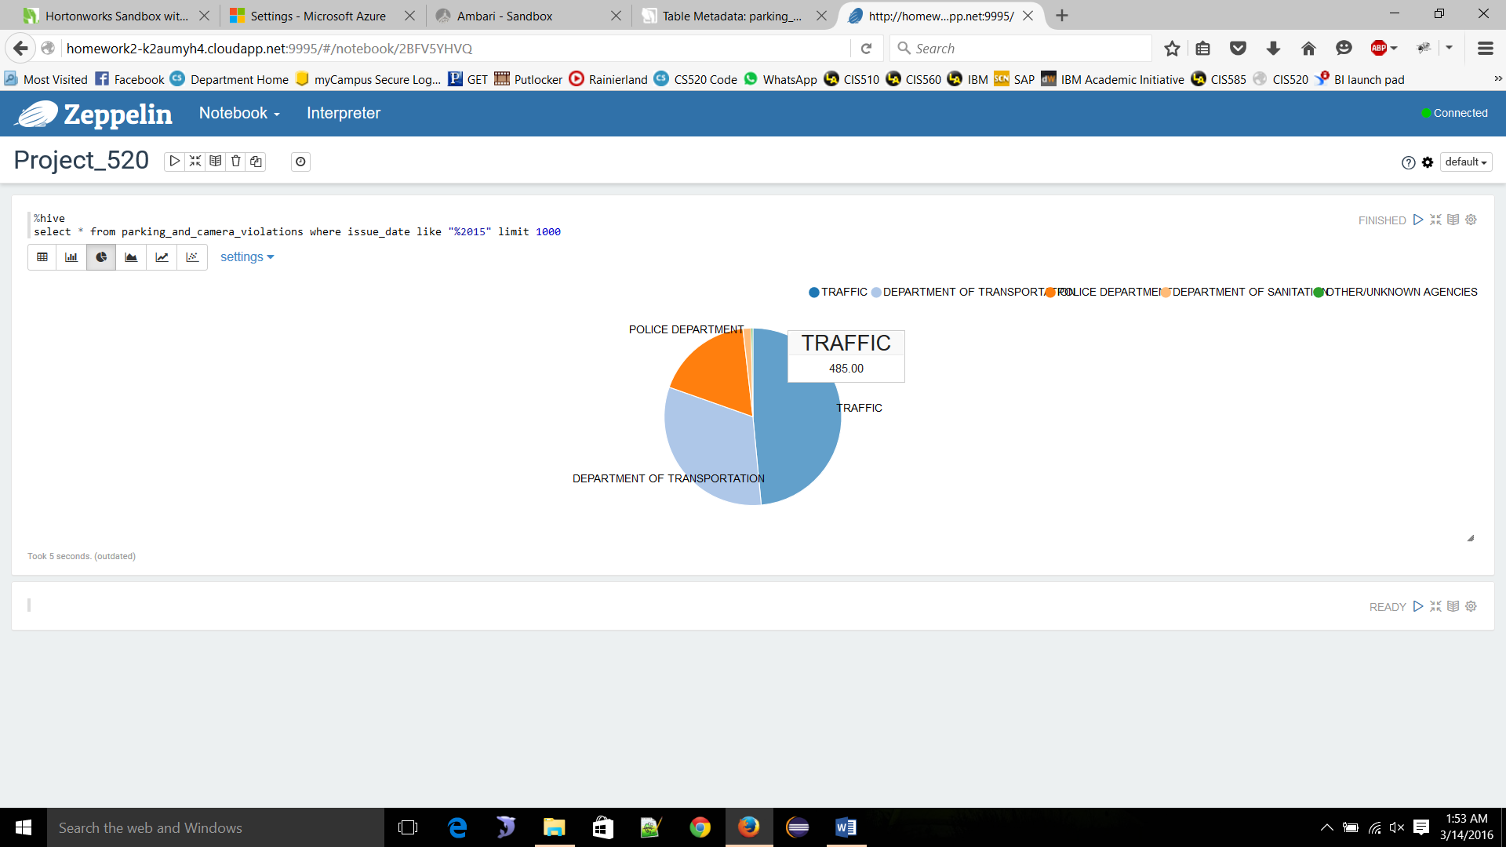

**🡪Violation Issue type**

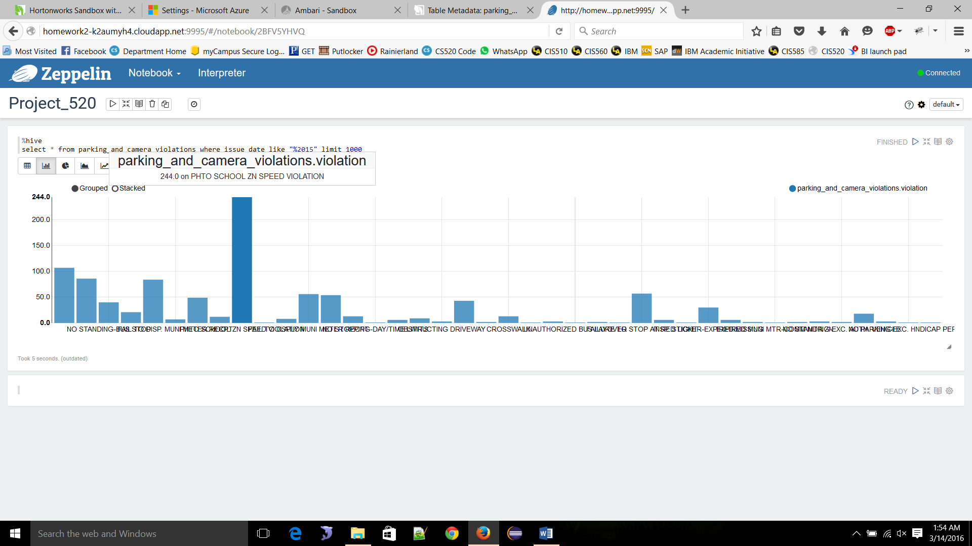

**🡪Violated state**

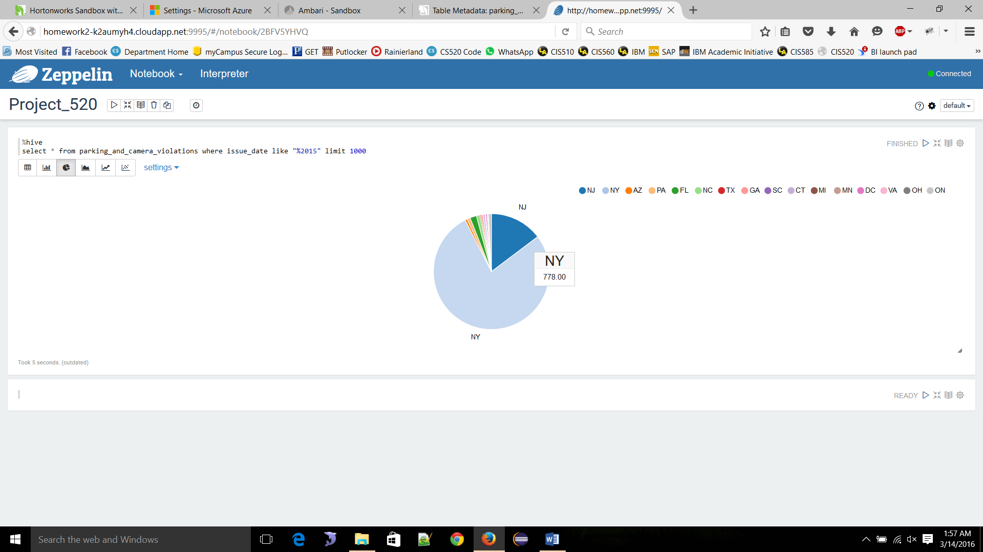  
  
🡪 **Violation fine amount**

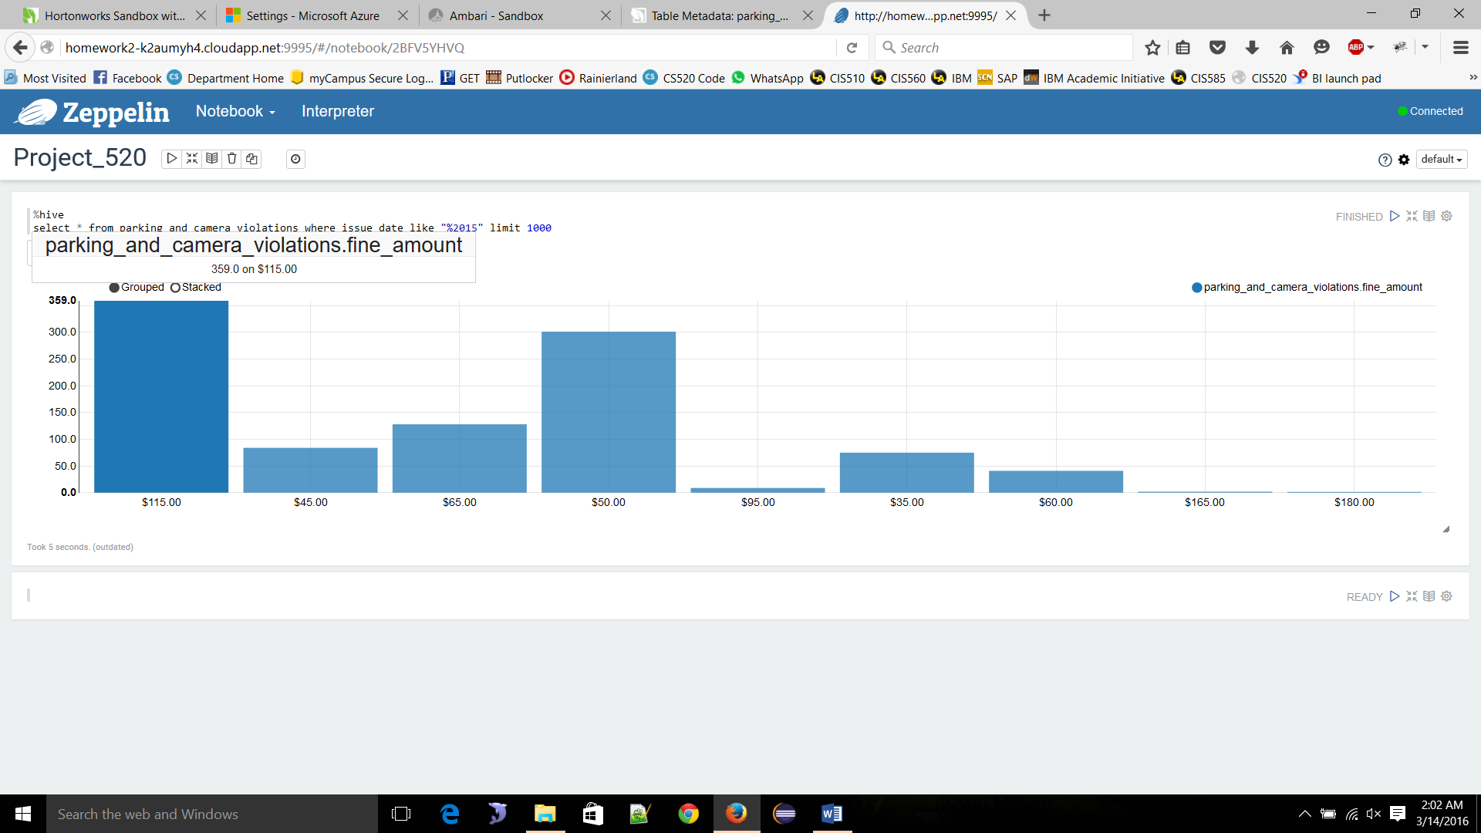

**STEP :13**

**Visualization in Tableau**  
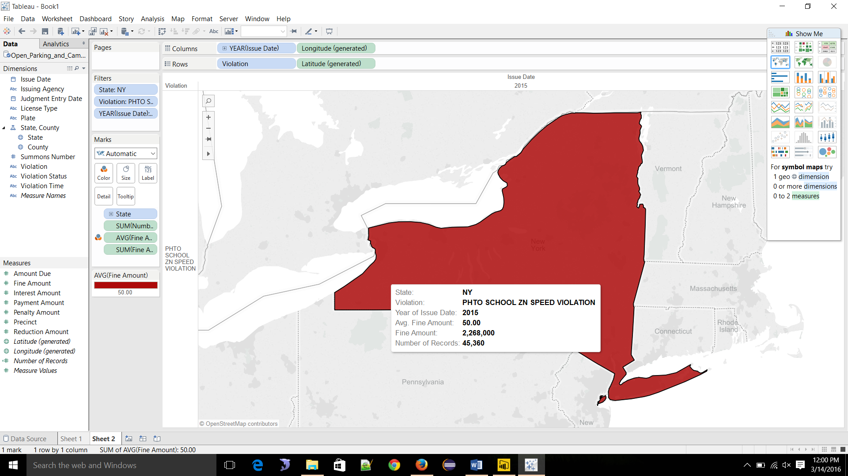

**STEP: 14**

**Power Bi NY state county vise**

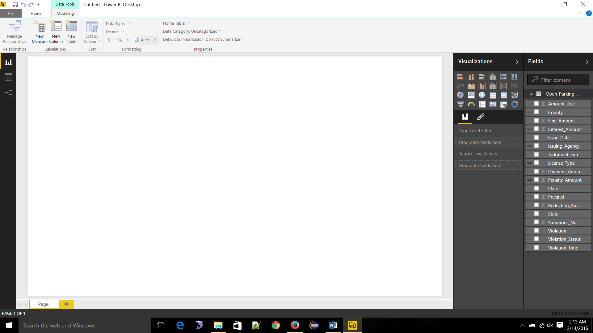  
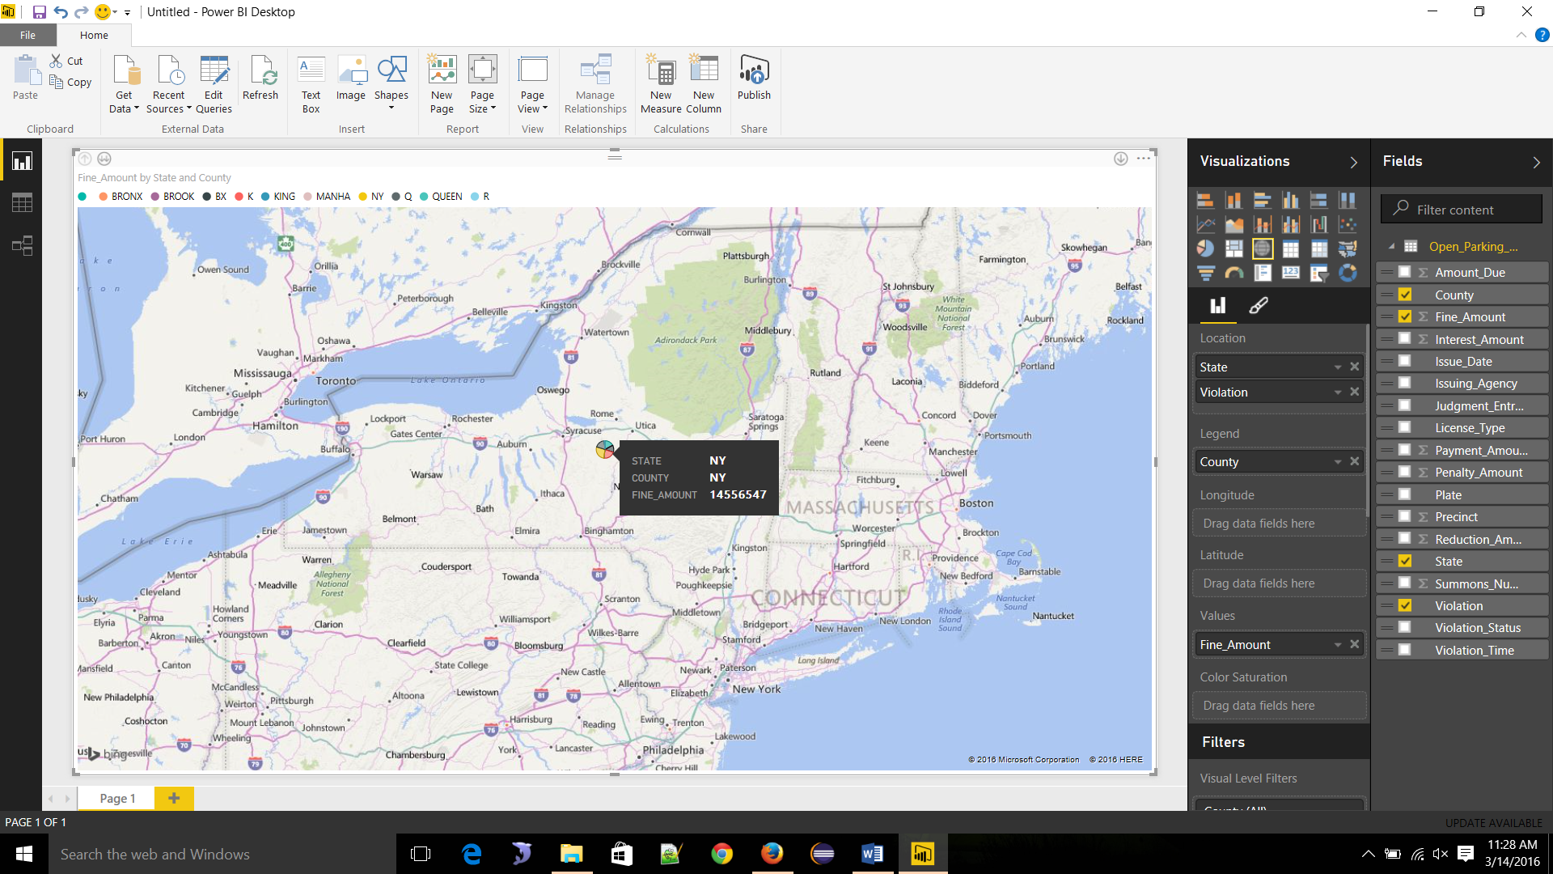

Links & reference

Dataset :  
<https://data.cityofnewyork.us/City-Government/Open-Parking-and-Camera-Violations/nc67-uf89>  
  
azure hortonworks sandbox with HDP 2.3.2:  
[https://portal.azure.com/#resource/subscriptions/49187439-970f-4c14-ba28-b945239fda34/resourceGroups/Group-1/providers/Microsoft.ClassicCompute/virtualMachines/homework2](https://portal.azure.com/%23resource/subscriptions/49187439-970f-4c14-ba28-b945239fda34/resourceGroups/Group-1/providers/Microsoft.ClassicCompute/virtualMachines/homework2)  
  
  
Support sandbox:  
<http://homework2-k2aumyh4.cloudapp.net:8888/>  
  
Shell in a box:  
<http://homework2-k2aumyh4.cloudapp.net:4200/>  
  
Ambari:  
[http://homework2-k2aumyh4.cloudapp.net:8080/#/main/dashboard/metrics](http://homework2-k2aumyh4.cloudapp.net:8080/%23/main/dashboard/metrics)  
  
Hue:  
<http://homework2-k2aumyh4.cloudapp.net:8000/about/>  
  
Zeppelin:  
[http://homework2-k2aumyh4.cloudapp.net:9995/#/](http://homework2-k2aumyh4.cloudapp.net:9995/%23/)

**Things we used**:   
1. Putty (SSH client for windows)

2. What else we used: (for graphical representation)  
3. Microsoft Excel 2013  
4. Tableau 9.2  
5. Microsoft Power BI